Project Report on

“**Online Grocery Management “**

**At**



**GIDC RAJJU SROFF ROFEL INSTITUTE OF MANAGEMENT**

**OF STUDIES (BBA) &**

**ROFEL SHRI G.M BILAKHIA COLLEGE OF APPLIED SCIENCES (BCA), VAPI**

###### [ISO 9001:2015, 29990-2010 Certified College]



**Affiliated to**

**Veer Narmad South Gujarat University, Surat++**

##### As a partial fulfilment For the degree of

Bachelor of Computer Application

#### (B. C. A.)

2024-2025

### Guided By: Submitted By:

**Prof. KINJAL PATEL CHANDAN KUSHWAHA**

**AAKASH PRAJAPATI  
 ADARSH PRAJAPATI**

**Acknowledgement**

We take this opportunity to thank all those who have contributed their support in preparing this seminar. Firstly, we would like to express our deep sense of gratitude towards ROFEL BBA and BCA College, Vapi.

Providing us this opportunity to implement our skills in making **Project** on a topic in our sixth semester course curriculum.

I would not miss the opportunity to thank my guide **Prof . KINJAL PATEL** who has always been providing continuous guidance & support and always been a stepping stone in completing this seminar.

I am also very thankful to Principal **Dr. P.H.Ved** of our college for their keen interest and for providing all facilities in our project work.

Last but not least, we are also grateful to our parents and friends whose continuous support

**Index**

|  |  |  |  |
| --- | --- | --- | --- |
| **Sr No.** | **Particulars** | | **Page no.** |
| **1.** | **Introduction** | | **04** |
| **1.1** | **Project profile** | **05** |
| **2.** | **Development Environment** | | **06** |
| **2.1** | **Development Tools (S/W & H/W**  **Specification)** | **09** |
| **2.2** | **Development Strategy (Process Model)** | **22** |
| **3.** | **System Analysis** | | **28** |
| **3.1** | **Requirement Gathering & Analysis** | **30** |
| **3.2** | **Scope of the System** | **29** |
| **3.3** | **Objectives** | **30** |
| **4.** | **Software Requirement specification** | | **36** |
| **4.1** | **E-R Diagram** | **38** |
| **4.2** | **Data Flow Diagram** | **39** |
| **4.3** | **Process Specification** | **48** |
| **4.4** | **Data Dictionary** | **51** |
| **5.** | **Testing** | | **58** |
| **6.** | **User Interface** | | **65** |
| **7.** | **Bibliography/ Webography** | | **72** |

|  |
| --- |
| INTRODUCTION |

### Project Overview

The **Online Grocery Management System** is a web-based platform that allows users to browse, select, and order groceries online. It provides an easy-to-use interface for customers to add products to their cart, place orders, and make payments. The admin manages products, stock, orders, and suppliers efficiently. Suppliers update stock details to ensure availability. This system reduces the hassle of physical shopping and saves time. It is built using PHP for the backend, with HTML, CSS, and animations for a user-friendly experience. The project enhances the online shopping experience with a smooth and organized grocery ordering process.

### Project Description

The **Online Grocery Management System** is a web-based platform that simplifies grocery shopping by allowing users to buy groceries online. Customers can browse a wide range of products, add them to their cart, and place orders with ease. This system provides a seamless shopping experience, eliminating the need for physical store visits.

It includes an **admin panel** that allows store managers to manage products, stock, orders, and supplier details efficiently. Admins can update product availability, track orders, and oversee inventory to prevent shortages.

Suppliers play a key role in maintaining stock levels by updating inventory, ensuring that customers get their desired products without delays. The system automates many manual processes, reducing errors and improving efficiency.

The goal is to **enhance convenience for both customers and store owners**, making grocery shopping faster and more organized. Built using **PHP, HTML, and CSS**, this system ensures a smooth, user-friendly, and responsive experience. It helps businesses streamline operations, handle orders efficiently, and provide better service to customers.

The Online Grocery Management System is a web-based platform that allows customers to browse, add groceries to their cart, and place orders online. It includes an admin panel for managing products, stock, orders, and suppliers efficiently. Built with PHP, HTML, and CSS, the system enhances convenience by making grocery shopping faster and more organized.

**1.1PROJECT PROFILE**

|  |  |
| --- | --- |
| Group Members: | Name: CHANDAN KUSHWAHA  Seat no.:6419  Name: ADARSH PRAJAPATI  Seat no:  Name: AAKASH PRAJAPATI  Seatno:298 |
| Project Title: | Online Grocery Management System |
| Project Type: | In-house Project |
| College Guide Name: | Prof. KINJAL |
| Hardware Configuration: | PROCESSOR: AMD Ryzen  5 5500u with radeon graphic 64-bit Operating system , x64-based processor |
| Software Configuration: | VS Code CHROME,  INTERNET EXPLORER. |
| Operating System: | Windows 11,10,11 |
| Platform: | Wamp Server |
| Project Technology: | PHP |
| Front End: | Html,Css,JavaScript,Bootstrap |
| Back End: | PHP,Php MyAdmin (MySQLI) |

**1.DEVELOPMENT ENVIORMENT**

* 1. **DEVLOPMENT TOOLS**

**HARDWARE CONFIGURATION :-**

PROCESSOR : AMD A6-9225 RADEON R4, 5 COMPUTE CORES

2C+3G, 2600Mhz, 2 Core(s), 2 Logical Processor(s)

HARD DISK : 500

RAM : 8GB

**SOFTWARE CONFIGURATION :-**

OPERATING SYSTEM : Windows 11.

FRONT-END : Html, CSS, JavaScript, XML, Java

BACK-END PHP MySQL

HELP TOOL : VS Code , Notepad++,WampServer Programing languages : Php7, MYSQLI, Ajax, JavaScript, jQuery.

## PROGRAMING LANGAUGES

PHP is platform independent application made it can be run on way operation system such as windows10, XP, UNIX.

###### What is PHP7?

PHP 7 is a major release of PHP programming language and is touted to be a revolution in the way web applications can be developed and delivered for mobile to enterprises and the cloud. This release is considered to be the most important change for PHP after the release of PHP 5 in 2004.

* PHP Stands for PHP: Hypertext Pre-processor
* PHP is a server-side scripting language, like ASP PHP scripts are executed on the server
* PHP supports many databases (MySQL, Informix, Oracle, Sybase, solid

,PostgreSQL ,Generic, etc.)

* PHP is an open-source software
* PHP is free to download and use

7

###### What is PHP File?

* PHP files can contain text, HTML tags and scripts
* PHP files are returned to the browser as plain HTML
* PHP files have a file extension of “.php”,”.php3”,or “.phtml”.

###### Why PHP?

* PHP runs on different platform (Windows, Linux, Unix, etc.)
* PHP is compatible with almost all servers used today (Apache, IIs ,etc.)
* PHP is free to download from the official PHP resource: [www.php.net](http://www.php.net/)
* PHP is easy to learn and runs efficiently on the server side.

## XAMPP

###### What is XAMPP and functionality?

XAMPP is a free and open-source cross-platform web server solution stack package developed by Apache Friends, consisting mainly of the Apache HTTP Server, MariaDB database, and interpreters for scripts written in the PHP and Perl programming languages. Since most actual web server deployments use the same components as XAMPP, it makes transitioning from a local test server to a live server possible.

**Introduction to XAMP**

XAMPP is a cross-platform web server that is free and open-source. XAMPP is a short form for Cross-Platform, Apache, MySQL, PHP, and Perl.

XAMPP is a popular cross-platform web server that allows programmers to write and test their code on a local webserver.

It was created by Apache Friends, and the public can revise or modify its native source code.

It includes Maria DB, Apache HTTP Server, and interpreters for PHP and Perl, among other computer languages. Because of XAMPP’s simplicity of deployment, a developer can quickly and easily install a WAMP or LAMP stack on an operating system, with the added benefit that common add-in apps like WordPress and Joomla can also be loaded.

### Need for XAMPP

XAMPP is simply a local host or server.

This local server runs on your personal computer, whether it’s a desktop or a laptop. It is used to test clients or websites before publishing them to a remote web server.

On a local computer, the XAMPP server software provides a suitable environment for testing MYSQL, PHP, Apache, and Perl projects. Because most real-world web server deployments share the same components as XAMPP, moving from a local test server to a live server is straightforward.

## ADVANTAGES AND DISADVANTAGES OF XAMPP

**ADVANTAGE:**

* + In comparison to other web servers such as WAMP, it is simple to set up.
  + It is Multi Cross-Platform, which implies it works on both Windows and Linux. With a single command, you may start and stop the entire webserver and database stack.
  + Both a full and a standard version of XAMPP are available.
  + It has a control panel that you can see contains start and stop buttons for specific mechanisms, such as Apache, which is running through its Control Panel.
  + It also includes OpenSSL, phpMyAdmin, MediaWiki, Joomla, WordPress, and a lot of additional modules.

## DISADVANTAGES:

* + In comparison to the WAMP server, configuration and setting are more difficult.

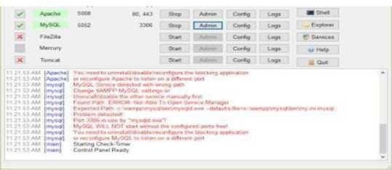

* + PHP MY ADMIN

### Security

We want to thank the following individuals for reporting vulnerabilities responsibly and helping improve XAMPP.

* Maximilian Barz
* Osanda Malith Jayathissa
* Kamil Sevi
* Simone Memoli (Toxic Security Team)
* Muhammad Talha Khan
* Vlad Ciornei
* Minh Nguyen (Sangteamtham)
* Avinash Kumar Thapa (-Acid)
* John Page (hyp3rlinx)
* CongRong（Tr3jer)
* Kusol Watchara-Apanukorn / Nissana Sirijira-al

### Support & QA

* Benny Stein
* Christian 'kleinweby' Speich
* Henning 'boppy' Bopp
* Stefan 'DeepSurfer' König
* nemesis Retired
* DJ DHG
* PF4
* Carsten Wiedmann
* Antivirus
* Apache-User
* Kristian W. Marcroft

### The Licence

XAMPP is a compilation of free software (comparable to a Linux distribution), it's free of charge and it's free to copy under the terms of the GNU General Public Licence. But it is only the compilation of XAMPP that is published under GPL. Please check every single licence of the contained products to get an overview of what is, and what isn't, allowed. In the case of commercial use please take a look at the product licences (especially MySQL), from the XAMPP point of view commercial use is also free.

### Features

* Web interface
* MySQL and MariaDB database management
* Import data from [CSV an](https://en.wikipedia.org/wiki/Comma-separated_values)[d](https://en.wikipedia.org/wiki/SQL) [SQL](https://en.wikipedia.org/wiki/SQL)
* Export data to various formats: [CSV,](https://en.wikipedia.org/wiki/Comma-separated_values) [SQL](https://en.wikipedia.org/wiki/Comma-separated_values)[,XML,PDF(v](https://en.wikipedia.org/wiki/XML)ia the [TCPDF](https://en.wikipedia.org/wiki/TCPDF) [li](https://en.wikipedia.org/wiki/TCPDF)brary), ISO/IEC 26300 - OpenDocument Text and

Spreadsheet, Word, Excel, [LaTeX an](https://en.wikipedia.org/wiki/LaTeX)d others

* Administering multiple servers
* Creating PDF graphics of the database layout
* Creating complex queries using query-by-example (QBE)
* Searching globally in a database or a subset of it
* Transforming stored data into any format using a set of predefined functions, like
* displaying [BLOB-da](https://en.wikipedia.org/wiki/BLOB)ta as image or download-link

## MYSQLI

The MySQL Extension (MySQL Improved) is a relational database driver used in the PHP scripting language to provide an interface with MySQL databases. There are three main API options when considering connecting to a MySQL database server:

* + PHP's MySQL Extension
  + PHP's MySQLi Extension
  + PHP Data Objects (PDO)

The PHP code consists of a core, with optional extensions to the core functionality. PHP's MySQL-related extensions, such as the MySQLi extension, and the MySQL extension, are implemented using the PHP extension framework. An extension typically exposes an API to the PHP developer, to allow its facilities to be used programmatically. However, some extensions which use the PHP extension framework do not expose an API to the PHP developer.

The PDO MySQL driver extension, for example, does not expose an API to the PHP developer, but provides an interface to the PDO layer above it.

MySQLi is an improved version of the older PHP MySQL driver, offering various benefits.

The authors of the PHP scripting language recommend using MySQLi when dealing with MySQL server versions 4.1.3 and newer (takes advantage of new function)

MySQL is a fast, easy-to-use RDBMS being used for many small and big businesses. MySQL is developed, marketed and supported by MySQL AB, which is a Swedish company. MySQL is becoming so popular because of many good reasons.

MySQL is released under an open-source license. So you have nothing to pay to use it.

MySQL is a very powerful program in its own right. It handles a large sub set of the functionality of the most expensive and powerful database packages.

MySQL uses a standard form of the well-known SQL data language.

MySQL works on many operating systems and with many languages including PHP, PERL, C,C++, JAVA, etc.

MySQL works very quickly and works well even with large data sets.

MySQL is very friendly to PHP, the most appreciated language for web development.

MySQL supports large databases, up to 50 million rows or more in a table. The default file size limit for a table is 4GB, but you can increase this (if your operating system can handle it) to a theoretical limit of 8 million terabytes (TB).

MySQL is customizable. The open-source GPL license allows programmers to modify the MySQL software to fit their own specific environments

## PHP+MYSQLI

* PHP combined with MySQL are cross platform (you can develop in windows and servers on a unix platform)

PHP is easy to learn and runs efficiently on server side.

### JavaScript

Javascript is a dynamic computer programming language. It is lightweight and most commonly used as a part of web pages, whose implementations allow client-side script to interact with the user and make dynamic pages. It is an interpreted programming language with object-oriented capabilities.

JavaScript was first known as **LiveScript,** but Netscape changed its name to JavaScript, possibly because of the excitement being generated by Java. JavaScript made its first appearance in Netscape 2.0 in 1995 with the name **LiveScript**. The general-purpose core ofthe language has been embedded in

Netscape, Internet Explorer, and other web browsers.

The [ECMA-26](http://www.ecma-international.org/publications/index.html)2 Specification defined a standard version of the core JavaScript language.

* + JavaScript is a lightweight, interpreted programming language.
  + Designed for creating network-centric applications.
  + Complementary to and integrated with Java.
  + Complementary to and integrated with HTML.
    - Open and cross-platform

### Why Use Bootstrap?

* **Mobile first approach** - Bootstrap 3, framework consists of Mobile first styles throughout the entire library instead them of in separate files
* **Browser Support** - It is supported by all popular browsers.
* **Easy to get started** - With just the knowledge of HTML and CSS anyone can get started with Bootstrap. Also the Bootstrap official site has a good documentation.
* **Responsive design** - Bootstrap's responsive CSS adjusts to Desktops, Tablets and Mobiles.
* Provides a clean and uniform solution for building an interface for developers.
* It contains beautiful and functional built-in components which are easy tocustomize.
* It also provides web based customization.
* And best of all it is an open source.

### Visual Studio Code

Visual Studio Code is a source-code editor that can be used with a variety of programming languages, including [Java,](https://en.wikipedia.org/wiki/Java_(programming_language)) [JavaScript,](https://en.wikipedia.org/wiki/JavaScript) [Go,](https://en.wikipedia.org/wiki/Go_(programming_language)) [Node.is,](https://en.wikipedia.org/wiki/Node.js) [Python](https://en.wikipedia.org/wiki/Python_(programming_language)) [an](https://en.wikipedia.org/wiki/Python_(programming_language))[d](https://en.wikipedia.org/wiki/C%2B%2B) [C++.](https://en.wikipedia.org/wiki/C%2B%2B)

It is based on the [Electron](https://en.wikipedia.org/wiki/Electron_(software_framework)) [fr](https://en.wikipedia.org/wiki/Electron_(software_framework))amework, which is used to develop [Node.is](https://en.wikipedia.org/wiki/Node.js) [Web](https://en.wikipedia.org/wiki/Node.js) [applications](https://en.wikipedia.org/wiki/Web_application) [t](https://en.wikipedia.org/wiki/Web_application)hat run on the [Blink layout engine.](https://en.wikipedia.org/wiki/Blink_layout_engine)

Visual Studio Code employs the same editor component (codenamed "Monaco") used in [AzureDevOps](https://en.wikipedia.org/wiki/Azure_DevOps_Server) [(](https://en.wikipedia.org/wiki/Azure_DevOps_Server)formerly called Visual Studio Online and Visual Studio Team Services).

Out of the box, Visual Studio Code includes basic support for most common programming languages. This basic support includes [syntax highlighting,](https://en.wikipedia.org/wiki/Syntax_highlighting) [bracket matching,](https://en.wikipedia.org/wiki/Bracket_matching) [code folding,](https://en.wikipedia.org/wiki/Code_folding) and configurable snippets.

Visual Studio Code also ships with [IntelliSense](https://en.wikipedia.org/wiki/Intelligent_code_completion) [fo](https://en.wikipedia.org/wiki/Intelligent_code_completion)r JavaScript, TypeScript, [JSON,](https://en.wikipedia.org/wiki/JSON) [CSS,](https://en.wikipedia.org/wiki/CSS) and [HTML,](https://en.wikipedia.org/wiki/HTML) as well as debugging support for Node.js. Support for additional languages can be provided by freely available extensions on the VS Code Marketplace.

Instead of a project system, it allows users to open one or more directories, which can then be [saved in workspaces for future reuse. This allows it to](https://en.wikipedia.org/wiki/Language-agnostic) [operate as a](https://en.wikipedia.org/wiki/Language-agnostic) [language-agnostic code editor for any language. It supports many](https://en.wikipedia.org/wiki/Language-agnostic) [programming languages and a set of](https://en.wikipedia.org/wiki/Language-agnostic) features that differs per language.

Unwanted files and folders can be excluded from the project tree via the settings. Many Visual Studio Code features are not exposed through menus or the user interface but can be accessed via the command palette.This is beyond

a doubt the most useful feature. There’s a comprehensive list of extensions available for VS Code in the [online marketplace,](https://marketplace.visualstudio.com/) [wh](https://marketplace.visualstudio.com/)ich has existed since mid- 2015.Installing extensions is as easy as clicking one button. You can manage them easily, including updating and disabling. It’s all very slick and works flawlessly, and [the website](https://code.visualstudio.com/docs/extensions/overview) [sh](https://code.visualstudio.com/docs/extensions/overview)ows how you can create your own extensions and publish them to the marketplace.

Whether you’re a professional web developer or you’re just getting started, the benefits of a faster workflow can be fantastic. In this article, we’ll dive into how to set-up an optimal workflow using Visual Studio Code.

Visual Studio Code comes with a lot of great features built-in, but add in the large (and growing) pool of extensions and you end up with thousands of ways to customise your experience.

While this is one of VS Code’s core strengths, it can also be overwhelming — especially for newer users. This article intends to cut through the noise. In it, I’ll share the most powerful techniques I use every day to work as quickly and effectively as possible.

The article is intended for two main types of people:

Beginners, who are just starting out with VS Code and want to make sure they’re using the same tools as the pros.

Intermediate users, who know VS Code quite well, but still feel they like they could make some improvements to their workflow.

Since its release in 2015, Microsoft’s Visual Studio Code has quickly established itself as the most popular code editor out there. In the last two years, evidence from Google’s search trends would indicate that interest in VS Code (in red, below) has overtaken that of all other major text editors:

Here are 7 great reasons why you might want to use a VSCODE.

* 7 Essential Features of Visual Studio Code for Web Developers. Optimise your web development workflow using VS Code's most powerful features and extensions. ...
* Emmet Abbreviations. ...
* The Integrated CLI (Command Line Interface) ...
* ESLint. ...
* Prettier. ...
* Multi-Cursor Shortcuts. ...
* Text Wrap. ...
* Execute and Debug JavaScript.

So whether you agree with me or not I would like to hear your comments below. Let me know what you think the answer to the is age-old question is. Thanks for any comments or replies.

###### Debugging?

While VS Code isn’t quite a full IDE, you can install and run debuggers (it even comes with one for JavaScript). The marketplace includes 68 free debuggers, including C/C++, Java, PHP, Python, Ruby, C#, Go, Lua, Haxe , Android and other.

### 2.1Development strategy

###### Software Evolution

Over time, software systems, programs as well as applications, continue to develop. These changes will require new laws and theories to be created and justified. Some models as well would require additional aspects in developing future programs. Innovations and improvements do increase unexpected form of software development. The maintenance issues also would probably change as to adapt to the evolution of the future software.

Software process and development are an ongoing experience that has a never- ending cycle. After going through learning and refinements, it is always an arguable issue when it comes to matter of efficiency and effectiveness of the programs

**Activates:**

**System Initiation/Planning:** where do systems come from? In most situations, new feasible systems replace or supplement existing information processing mechanisms whether they were previously automated, manual, or informal.

**Requirement Analysis and Specification**: identifies the problems a new software system is suppose to solve, its operational capabilities, its desired performance characteristics, and the resource infrastructure needed to support system operation and maintenance.

**Functional Specification or Prototyping:** identifies and potentially formalizes the objects of computation, their attributes and relationships, the operations that transform these objects, the constraints that restrict system behavior, and so forth.

**Partition and Selection (Build vs. Buy vs. Reuse**): given requirements and functional specifications, divide the system into manageable pieces that denote logical subsystems, then determine whether new, existing, or reusable software systems correspond to the needed pieces.

**Architectural Design and Configuration Specification**:

defines the interconnection and resource interfaces between system subsystems, components, and modules in ways suitable for their detailed design and overall configuration management.

**Detailed Component Design Specification:** defines the procedural methods through which the data resources within the modules of a component are transformed from required inputs into provided outputs.

**Component Implementation and Debugging:** codifies the

preceding specifications into operational source code implementations and validates their basic operation.

**Software Integration and Testing**: affirms and sustains the overall integrity of the software system architectural configuration through verifying the consistency and completeness of implemented modules, verifying the resource interfaces and interconnections against their specifications, and validating the performance of the system and subsystems against their requirements.

#### NORMALIZATION

Normalization is a step by step process for designing relations and relationships. Normalization reduces redundancy using the principle of non- less decomposition is the reduction of the table to smaller table without any loss of information. This enable manipulation of the database in a powerful way, minimizes data anomalies and inconsistencies, improves data independence and helps to create flexible design. A fully normalized record consist of:7

* + 1. A primary key that identifies that entity.
    2. A set attribute that describes that entity.

###### Normal form:

Normalization result in the formation of tables that satisfy certain specified constraints, and represent certain normal forms.

Several normal forms have been identified, the most important and widely used of this are:

1. First normal form(1 NF)
2. Second normal form(2 NF)
3. Third normal form(3 NF)
4. Boy cee code normal form(BCNF)

###### Functional dependency

Given that A and B be composite attributes and R is a relation. Attribute A is functionally dependent on B, If each value of A in R is associate with precisely one value of B.

###### First normal form

This is the lowest level of normalization. It states that data is in first normal form, if the pool of valid values that may appear in attributes contains only atomic values.(atomic values can not bede composed into smaller unit).each contains only one value in any row of a table.

###### Second normal form

Data is in second normal form if it is in 1NF and every attribute in the record is functionally depend upon the whole key and not a just a part of the key.(N attribute is a non key if it is not part of the primary key). The purpose of 2NF is to eliminate repeating groups of N to ensure that the remaining attributes belong to this entity. N attribute is functionally parallel depends on a key, if the attribute contains only one value which depends on the key.

###### Third normal form

Data is in third normal form and only if it is in 2NF and every non key attribute is non transitivity depend on the primary key. The purpose of 3NF is to ensure that the attributes directly to the entity.

###### Other normal form

The other normal form boy cee code normal form (BCNF), 4th normal form and 5th normal form. They are seldom used.

### 2.2Development Strategy (Process Model) Incremental model

###### What is Incremental Model?

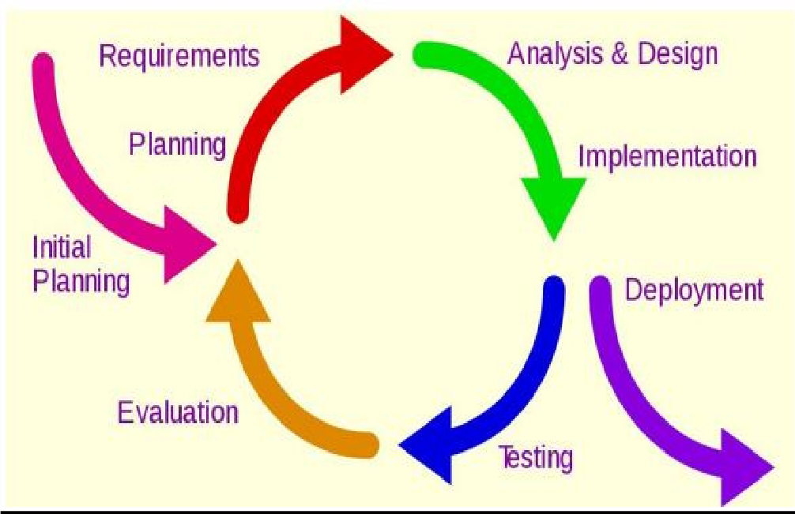Incremental Model is a process of software development where requrements are broken down into multiple standalone modules of software development cycle.

The **incremental build model** is a method of software development where the product is designed, implemented and tested incrementally (a little more is added each time) until the product is finished. It involves both development and maintenance. The product is defined as finished when it satisfies all of its requirements. This model combines the elements of the waterfall model with the iterative philosophy of prototyping.

The product is decomposed into a number of components, each of which is designed and built separately (termed as builds). Each component is delivered to the client when it is complete. This allows partial utilization of the product and avoids a long development time. It also avoids a large initial capital outlay and subsequent long waiting period. This model of development also helps ease the traumatic effect of introducing a completely new system all at once.

The incremental model applies the waterfall model incrementally.

The series of releases is referred to as “increments”, with each increment providing more functionality to the customers. After the first increment, a core product is delivered, which can already be used by the customer. Based on customer feedback, a plan is developed for the next increments, and modifications are made accordingly. This process continues, with increments being delivered until the complete product is delivered. The incremental philosophy is also used in the agile process model

The Incremental model can be applied to DevOps. In DevOps it centers around the idea of minimizing risk and cost of a DevOps adoption whilst building the necessary in-house skillset and momentum.

Each iteration passes through the requirements, design, coding and testing phases. And each subsequent release of the system adds function to the previous release until all designed functionality has been implemented

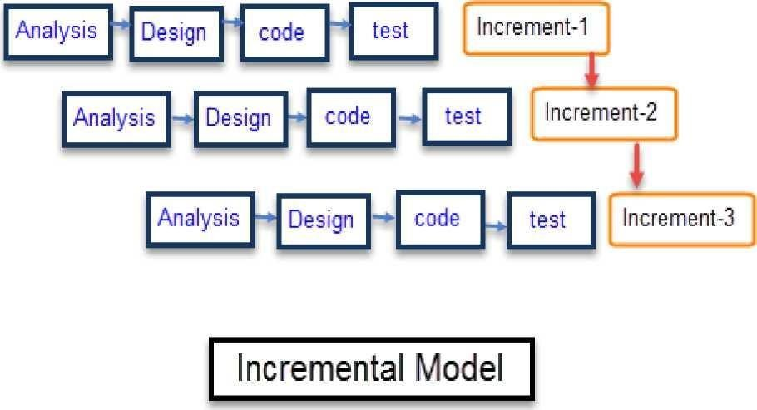

|  |  |
| --- | --- |
| Incremental  Phases | Activities performed in incremental phases |
| Requirement  Analysis | Requirement and specification of the  software are collected |
| Design | Some high-end function are designed  during this stage |

|  |  |
| --- | --- |
| Code | Coding of software is done during this  stage |
| Test | Once the system is deployed, it goes  through the testing phase. |

##### Advantages

* Software will be generated quickly during the software life cycle
* It is flexible and less expensive to change requirements and scope
* Though the development stages changes can be done
* This model is less costly compared toothers

##### Disadvantages

* + It requires a good planning designing
  + Problems might cause due to system architecture as such not all requirements
  + Each iteration phase is rigid and does not overlap each other
  + Rectifying a problem in one unit requires correction in all the units

### 3 .System Analysis

* PRESENCE SYSTEM
* REQUIRMENT GATHERING & ANALYSIS
* SCOPE OF SYSTEM
* OBJECTIVES

**PRESENCE SYSTEM:**

Software is always part of large system or business work beginnings by establishing requirement for all system elements and then allocating some subset of these requirements to software. This system view is essential when software must interface with other elements such as hardware, people and databases. System engineering and analysis encompasses requirements gathering at the business area level.

System study is most important stag of software development life cycle while attempting to convert the manual process to computerized process. System study can be carefully defined as “a study of the operations or a set of connected elements and of the inner connection between these elements”.

The process of building a system has been always complex. In recent years, however with the system becoming larger and costlier, the complexities have multiplied. So the need for better method for developing system is widely recognized. An applied model of the system should meet a few basic requirements:

* The model should utilize established methods and techniques, for example, concepts such as database designs and structured programming.
* The model should be structured and should cover the entire system development process from feasibility study to programming.
* The model should consist of “building blocks” which will define task result and interfaces. The models should separate the logical system (the actual needs of the user) from the physical system (the system to be implemented)
* Documentation should be a direct result of the development work and should be concise, precise and as non-redundant as possible.

Based on the above requirement of the system of the system model, system study was done. The study covered the overall functionality of the existing system was done by interviewing the personal involved and questionnaires distributed to them were they processed and studied sample document.

## 3.1REQUIRMENT ANALYSIS

User any system when supposed to be developed it is essential that the designer follows the step of software development life cycle (SDLC). SDLC consists of various integrated steps all levels of software development SRS (System Requirement Analysis) is the first technique step in SDLC.

**REQUIREMENTS**

* + - User Friendly.
    - All relevant information should be displayed on the screen. + Should provide easy hard copy.
    - Easy access to details.
    - Valuable statistical information should be available.
    - Timely reports should be generated.
    - Minimum mouse usage and maximum keyboard should be facilitated.
    - Graphical charts should be available.

**SYSTEM REQUIREMENT**

System and utility department of Fast treack shop require a complete solution a computerize their product functionality. For this they want to maintain all details of the product coming for processing.

**FUNCTIONAL REQUIREMENTS:**

Function requirements meant the process to be performed by the system to achieve the desire output:

* + - Output drives the inputs flow through the system.
    - Invalid inputs should be avoided and appropriate message will be displayed.
    - The data should have an easy and smooth flow through the system and the integrity of the data should maintain.

**DESIGN CONSTRAINTS**

These are the facts present in client’s environment that many restrict the choice of a designer. Such factors include standards that must followed, resource limits, operating environment, reliability and security.

The reliability of the project depicts the extent to which it does not fail. The software should be bug free. Security is a must whenever a larger database is involved. Some situations should be handled carefully.

###### Simplified design of the software should be the prime goal:

* + - The design should be easy to understand.
    - It should be stable.
    - It should be flexible in nature.

**PERFORMANCE REQUIREMENTS:**

This part of SRS specifies the performance constraint on the software system. There are two type of requirement they are:

###### Static Requirement:

Static requirement is those that do not impose constraint on the execution of the software but on the capability requirements of the system. This software is to besingle user software.Terminal needed should be on only one. It should be easy to handle several files and normal sized databases.

###### Dynamic Requirement:

Dynamic requirement is those they specify constraints on the execution of the system. These include the response time and throughput constraint on the system.The response time should be minimum in order that the through put is high.

* + faster processing speed.
  + should support multi-user.
  + very little response time.

###### External Interface Requirement:

This refers to the screen design i.e. the user interface. The screen layout Should be attractive with the various controls well spaced and compact. Standard Pertaining should be simple and attractive having catchy layouts and screen design.

###### Coding Specifications option:

In maintains and certain there should be for creation,

changes and display in the create phase, a new entry is to be added to other. During the change desired and then edit the fields for which changes are inculpated. It will update in the respective table on the saving the information. During the display phase one has to select the key field for which the information is to be displayed. No modification is to be allowed in this phase.

## 3.2SCOPE OF THE SYSTEM

The **Online Grocery Management System** aims to streamline the process of purchasing groceries by providing an efficient and user-friendly digital platform for customers, suppliers, and administrators. The system automates essential operations such as product management, order processing, inventory tracking, and supplier coordination, ensuring a seamless shopping experience

.

**Key Features and Functionalities:**

**For Customers:**

User-friendly interface for browsing and searching grocery items.

"My Cart" feature to add, update, or remove products before checkout.

Secure online payment options and order tracking.

Personalized recommendations and discount offers.

**For Admins:**

Dashboard for managing user accounts, products, orders, and inventory.

Stock management system to track available and low-stock products.

Supplier management to coordinate product restocking.

Reports and analytics for business insights.

**For Suppliers:**

Interface for suppliers to manage stock and deliveries.

Notifications for new orders and stock updates.

**Future Enhancements:**

Mobile application for better accessibility.

AI-based recommendations for a personalized shopping experience.

Integration with third-party delivery services for faster delivery.

## 3.2GOALS OF THE PROPOSED SYSTEM:

###### Immediate retrieval of information

The main objective of the new system is to provide for quick and efficient retrieval of information. Any type of information would be available to the user whenever he requires. Facility would be provided for online query to cut down on the response time greatly.

###### Immediate storage of information

In the proposed system, it will be easy to store information at any given time at the correct places. The location of storage would be easily available and user will face no difficulty.

###### Prompt updating of information

In the proposed system, the information will always remain up to date as the updating will be prompt and without any efforts. This factor will be of great importance in the proposed system as it determines the integrity of the information stored.

###### Fast computation of information

The computation of information will be quite fast in the proposed system. Not only mathematical calculations, but also logical comparisons will be quick in the new system.

###### Planned approach toward working

The working in the service centre information system will be well planned and organized. The data will be stored properly in the data store, which will help in retrieval of information as well as in its storage.

###### Generation of managerial and strategic reports

The new system would provide for regular generation of reports, which would help the management in decisions making work and in controlling the overall working of the organization. The generation, of these reports would be possible only if the system is organized such that retrieval of information can be made on conditions.

###### Accuracy

The level of accuracy in the new proposed system would be higher. All operations and computations would be done correctly and this will ensure that whatever information is coming from the centre, it is accurate.

###### Reliability

The reliability of the proposed system would be high due to the above stated reasons. The reason for the increased reliability of the system is that now there would be proper storage of information, its maintenance would be well managed and retrieval would be possible in the desired manner.

###### Non-Redundant Information

In the new system, utmost care would be taken that no information is repeated, any usage of storage or otherwise. This would assure economic usage of storage or space and consistency in the data stored. This will also help make those changes easily as the change would have to be made only at that very place and nowhere else.

## 4.SOFTWARE REQUIREMENT SPECIFICATION

###### System Flow Diagram :

System Flowchart is the graphical representation of the flow of data in the system, and represents the work process of the system. Various symbols are used in the flowchart to designate specific action .

###### →Display



* + - Indicates data that is displayed for people to read such as data on monitor or projector screen.

###### →Process :

* + Indicates any processing function

###### →Database :

* Indicates a list of information with a standard structure that allows for searching and sorting.

###### Document :

* + - Indicates data that can be read by people such as printed output.

### Flowchat Diagram

### ER -Diagram

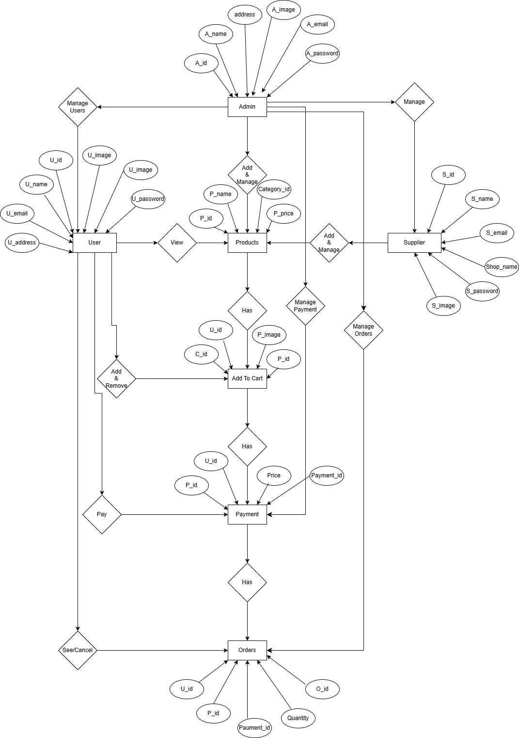

**4.2Data Flow Diagrams (DFD)**

A data flow diagram is graphical tool used to describe and analyze movement of data through a system. These are the central tool and the basis from which the other components are developed. The transformation of data from input to output, through processed, may be described logically and independently of physical components associated with the system. These are known as the logical data flow diagrams.

The physical data flow diagrams show the actual implements and movement of data between people, departments and workstations. A full description of a system actually consists of a set of data flow diagrams. Using two familiar notations Yourdon, Gane and Sarson notation develops the data flow diagrams. Each component in a DFD is labeled with a descriptive name. Process is further identified with a number that will be used for identification purpose.

The development of DFD’S is done in several levels. Each process in lower level diagrams can be broken down into a more detailed DFD in the next level. The lop-level diagram is often called context diagram. It consists a single process bit, which plays vital role in studying the current system. The process in the context level diagram is exploded into other process at the first level DFD.

The idea behind the explosion of a process into more process is that understanding at one level of detail is exploded into greater detail at the next level. This is done until further explosion is necessary and an adequate amount of detail is described for analyst to understand the process.

Larry Constantine first developed the DFD as a way of expressing system requirements in a graphical from, this lead to the modular design.A DFD is also known as a “bubble Chart” has the purpose of clarifying system requirements and identifying major transformations that will become programs in system design. So it is the starting point of the design to the lowest level of

detail. A DFD consists of a series of bubbles joined by data flows in the system.

## DFD SYMBOLS:

In the DFD, there are four symbols

* + 1. A square defines a source(originator) or destination of system data
    2. An arrow identifies data flow. It is the pipeline through which the information flows.
    3. A circle or a bubble represents a process that transforms incoming data flow into outgoing data flows.
    4. An open rectangle is a data store, data at rest or a temporary repository of data

Process that transforms data flow.

Source or Destination of data

Data flow

Data Store

#### DATA FLOW

1. A Data Flow has only one direction of flow between symbols. It may flow in both directions between a process and a data store to show a read before an update. The later is usually indicated however by two separate arrows since these happen at different type.
2. A join in DFD means that exactly the same data comes from any of two or more different processes data store or sink to a common location.
3. A data flow cannot go directly back to the same process it leads. There must be atleast one other process that handles the data flow produce some other data flow returns the original data into the beginning process.
4. A Data flow to a data store means update (delete or change).
5. A data Flow from a data store means retrieve or use.

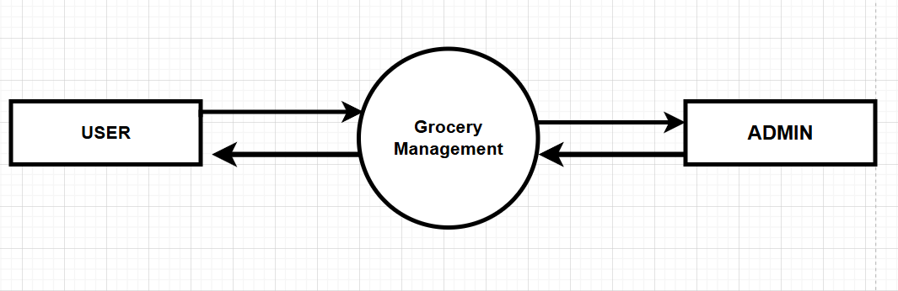

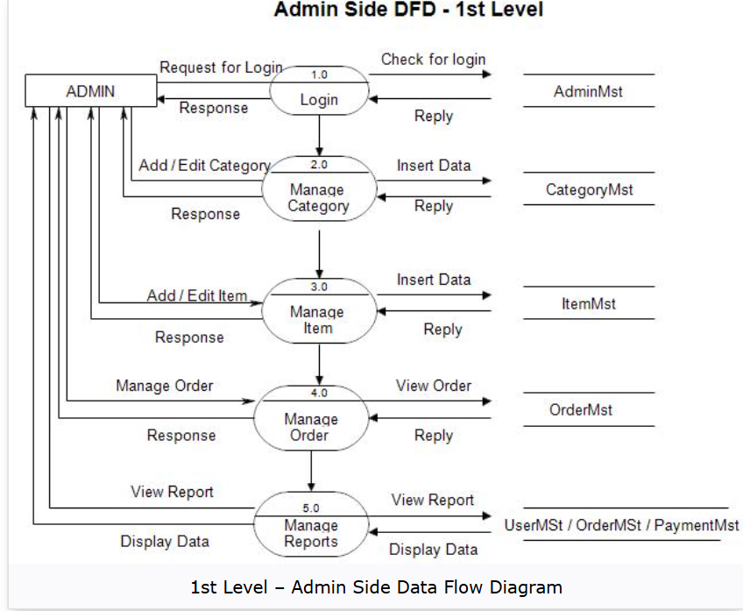

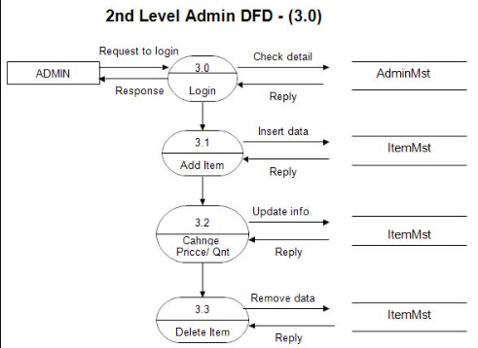

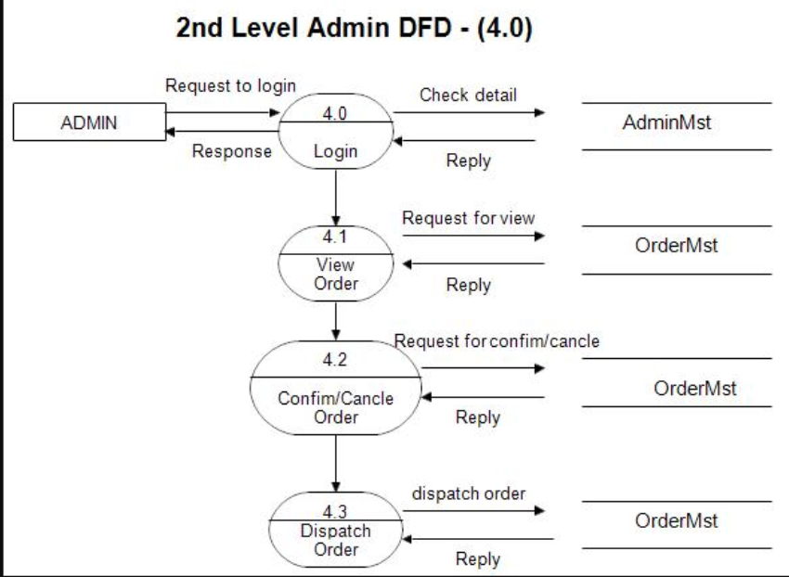

|  |
| --- |
| USER SIDE DFD |

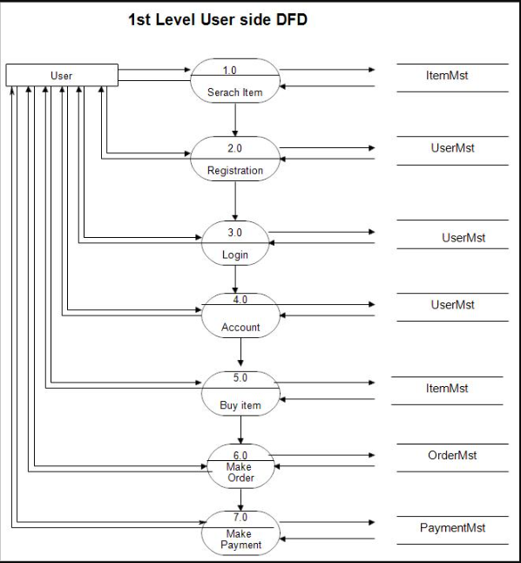

## 4.3 PROCESS SPECIFICATION

**ADMIN LOGIN PROCESS**

|  |  |  |
| --- | --- | --- |
| **1** | **Process No.** | **1** |
| **2** | Process Name | Admin Login Process |
| **3** | Description | Admin can Login |
| **4** | Input | User ID, Password |
| **5** | Output | Operate the System |

**USER LOGIN PROCESS**

|  |  |  |
| --- | --- | --- |
| **1** | **Process No.** | **2** |
| **2** | Process Name | User Login Process |
| **3** | Description | User can Login |
| **4** | Input | User ID, Password |
| **5** | Output | Operate the System |

**SUPPLIER LOGIN PROCESS**

|  |  |  |
| --- | --- | --- |
| **1** | **Process No.** | **2** |
| **2** | Process Name | Seller Login  Process |
| **3** | Description | Seller can Login |
| **4** | Input | Seller ID, Password |
| **5** | Output | Operate the System |

**USER REGISTRATION**

|  |  |  |
| --- | --- | --- |
| **1** | **Process No.** | **3** |
| **2** | Process Name | User registration Process |
| **3** | Description | User can registration |
| **4** | Input | User Details |
| **5** | Output | Register to the system |

**SELLER REGISTRATION**

|  |  |  |
| --- | --- | --- |
| **1** | **Process No.** | **3** |
| **2** | Process Name | Seller registration  Process |
| **3** | Description | Seller can registration |
| **4** | Input | Seller Details |
| **5** | Output | Register to the system |

**ADD PRODUCTS**

|  |  |  |
| --- | --- | --- |
| **1** | **Process No.** | **4** |
| **2** | Process Name | Add Products  Process |
| **3** | Description | Add New Products |
| **4** | Input | Products Details |
| **5** | Output | Add Products brand to system |

**ADD SHOP**

|  |  |  |
| --- | --- | --- |
| **1** | **Process No.** | **5** |
| **2** | Process Name | Add Shop Process |
| **3** | Description | Add Shop Car |
| **4** | Input | Shop Details |
| **5** | Output | Add new Shop to system |

**CATEGORY LISTING**

|  |  |  |
| --- | --- | --- |
| **1** | **Process No.** | **6** |
| **2** | Process Name | View Category list Process |
| **3** | Description | User can view the Category in  system |
| **4** | Input | Car Detail |
| **5** | Output | View Car |

**PRODUCTS ORDERING**

|  |  |  |
| --- | --- | --- |
| **1** | **Process No.** | **8** |
| **2** | Process Name | Products Ordering |
| **3** | Description | User can Order Products |
| **4** | Input | Products Details |
| **5** | Output | New Products |

**VIEW ORDERS**

**1**

**Process No.**

**9**

|  |  |  |
| --- | --- | --- |
| **2** | Process Name | View Orders Process |
| **3** | Description | View the order in system |
| **4** | Input | Orders Detail |
| **5** | Output | View Orders |

**SUPPLIER ADD PRODUCTS**

|  |  |  |
| --- | --- | --- |
| **1** | **Process No.** | **10** |
| **2** | Process Name | Seller Add Products |
| **3** | Description | Add New Products |
| **4** | Input | Products Details |
| **5** | Output | Add Product to system |

**PAYMENT**

|  |  |  |
| --- | --- | --- |
| **1** | **Process No.** | **11** |
| **2** | Process Name | PAYMENT |
| **3** | Description | Pay for Products |
| **4** | Input | Service |
| **5** | Output | Payment process begins |

### Data dictionary

1. Admin table

|  |  |  |  |  |
| --- | --- | --- | --- | --- |
| **Column Status** | **Attribute** | **Datatype** | **Size** | **Description** |
| **Primary key** | id | int | 10 | Admin identification number, it consists of  unique number |
| **Not null** | Name | varchar | 100 | Username of admin |
| **Not null** | Email | varchar | 100 | Email of Admin |
| **Not null** | Password | varchar | 255 | Password of admin |
| **Not null** | address | text | 100 | Address of ad |
| **Not null** | image | varchar | 255 | Profile image of admin |

2.Parent_category table

|  |  |  |  |  |
| --- | --- | --- | --- | --- |
| **Column Status** | **Attribute** | **Datatype** | **Size** | **Description** |
| **Not null Primary key** | id | int | 100 | identification number, it consists of unique  number |
| **null** | Name | varchar | 255 | It contains name of the  Product |
| **Not null** | Image | varchar | 255 | Parent category image |

3.Child_category table

|  |  |  |  |  |
| --- | --- | --- | --- | --- |
| **Column Status** | **Attribute** | **Datatype** | **Size** | **Description** |
| **Not null Primary key** | id | int | 100 | identification number, it consists of unique  number |
| **null** | Parent_id | int | 100 | identification number, Parent category |
| **null** | Name | varchar | 100 | It contains name of the  Child Category |
| **Not null** | Image | varchar | 100 | Child Category image |

4.Items table

|  |  |  |  |  |
| --- | --- | --- | --- | --- |
| **Column Status** | **Attribute** | **Datatype** | **Size** | **Description** |
| **Not null Primary key** | id | int | 100 | identification number, it consists of unique  number |
| **null** | Category_id | int | 100 | identification number, Parent category |
| **null** | Name | varchar | 100 | It contains name of the  Child Category |
| **Not null** | Description | varchar | 100 | Child Category image |
| **Not null** | price | decimal |  | Price of the product |
| **Not null** | Image | varchar | 255 | Image of the product |
| **Not null** | Offer | varchar | 50 | Offer on the product |
| **Not null** | Weight | Text |  | Product quantity and weight |
| **Not null** | Old_price | decimal | (10 , 2 ) | Price before discount |

5.orders - This table contains the information of the order

|  |  |  |  |  |
| --- | --- | --- | --- | --- |
| **Column Status** | **Attribute** | **Datatype** | **Size** | **Description** |
| **Not null Primary key** | id | int | 11 | identification number, it consists of unique  number |
| **null** | User id | int | 11 | Id of user |
| **null** | Name | varchar | 255 | It contains name of the  Product |
| **null** | Address | int | 11 | It contains address of  the Product |
| **No null** | email | timestamp |  | It contains email of  user |
| **null** | Product_Name | varchar | 50 | It Contain Name of the Product |
| **null** | Total_price | varchar | 55 | It contains Total Price of the order |
| **null** | Payment_id | varchar | 255 | It Contain Payment id  Of order |
| **null** | Payment_status | enum |  | It Contain Payment  Status of order |
| **null** | Order_date | timestamp |  | To Store real time |
| **null** | status | enum |  | It Contain status of order |

6.OTP_VERIFICATION

|  |  |  |  |  |
| --- | --- | --- | --- | --- |
| **Column Status** | **Attribute** | **Datatype** | **Size** | **Description** |
| **Not null Primary key** | Otp_id | int | 11 | Identification number, it consists of unique  number |
| **null** | User_id | int | 255 | It contains user id |
| **null** | otp | int | 16 | It contains user id |
| **null** | Create_at | timestamp |  | It contains login time |

7.Users

|  |  |  |  |  |
| --- | --- | --- | --- | --- |
| **Column Status** | **Attribute** | **Datatype** | **Size** | **Description** |
| **Primary key** | id | int | 10 | identification number, it consists of  unique number |
| **Not null** | FirstName | varchar | 100 | FirstName of user |
| **Not null** | LastName | varchar | 100 | LastName of user |
| **Not null** | Email | Varchar | 100 | Email of user |
| **Not null** | mobile | timestamp |  | Mobile number of user |
| **Not null** | Address | varchar | 100 | Password of user |
| **Not null** | image | varchar | 255 | Image od user |
| **Not null** | Create_at | timestamp |  | It Contain time and date |
| **Not null** | password | varchar | 255 | It Contain password of the user |
| **Not null** | status | enum |  | It Contain status of the user |

8.Supplier table

|  |  |  |  |  |
| --- | --- | --- | --- | --- |
| **Column Status** | **Attribute** | **Datatype** | **Size** | **Description** |
| **Not null Primary key** | id | int | 11 | Identification number, it consists of unique  number |
| **null** | FirstName | varchar | 255 | It contains first name of  the user |
| **null** | Shope | varchar | 255 | It contains Shope of the  user |
| **null** | email | varchar | 11 | It contains email of  the Product |
| **null** | Mobile | varchar | 255 | It contains mobile of  the user |
| **null** | Address | text |  | It contains shipping  Address of the user |
| **null** | image | varchar | 255 | It contains image of the user |
| **null** | Password | varchar | 255 | It contains password of the user |
| **null** | Status | Enum | 11 | It contains Status of the user |
| **null** | Create_at | Timestamp |  | It Contain review Date of  The product |

9.cart

|  |  |  |  |  |
| --- | --- | --- | --- | --- |
| **Column Status** | **Attribute** | **Datatype** | **Size** | **Description** |
| **Not null Primary key** | id | int | 11 | identification number, it consists of unique  number |
| **null** | U id | int | 11 | Id of user |
| **null** | image | varchar | 255 | It contains image of the Product |
| **null** | offer | int | 11 | It contains offer of  the Product |
| **No null** | name | varchar |  | It contains name of  product |
| **null** | weight | varchar | 50 | It Contain weight of the Product |
| **null** | price | varchar | 55 | It contains Price of the cart |
| **null** | Old_price | varchar | 255 | It Contain old price  Of cart |
| **null** | address | enum |  | It Contain address of order |
| **null** | Total_price | timestamp |  | It Contain total price of cart |
| **null** | quantity | enum |  | It Contain quantity of order |
| **Not null** | added_at | timestamp |  | Store time and date |

### 5.Testing

**SYSTEM TESTING AND IMPLEMENTATION**

White Box Testing and Black Box Testing in Software Testing Software testing is one of the best means to affirm the quality of software and deliver an error-free application. Over the years, software testing has matured into a separate discipline giving way to several different testing techniques that have been introduced, analyzed and studied in this area. Black box testing and white box testing are two such testing approaches that are quite commonly used by software testers.

System testing is a critical element of the software quality assurance and represents the ultimate review of specification, design and coding.

The increasing visibility of software as system and the attendant “costs” associated with a software failure forces for well planned, through testing. It is not unusual for a development organization to expand between 30 and 40 percent of total project effort on testing. In the extreme, testing of human-rated software can cost three as much as all other software engineering activates combined.

### White box Testing :

White box testing sometimes called glass-box testing is a test case design method that to use the control structure of the pal design to derive test case. Using white-box testing methods, the software engineer can derive text case that:

* Guarantee that all independent paths within a module have been exercised at least once
* Exercise all logical decisions on their true and false sides.
* Exercise all loops at their boundaries within their operational bounds.
* Exercise internal data structure to assure their validity.

### What is White Box Testing?

In white box testing methodology, the tester has the knowledge of the internals of a system and knows how the system is implemented. The tester uses this knowledge to develop test cases that will examine the control flow, information flow, data flow, exception and error handling as well as coding practices of the system.

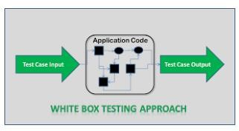

### How to write Test Cases for White Box Testing?

* The tester analyzes and understands the structure of the system by examining its code.
* The tester understands the weak spots within the code that is most prone to defects.
* The tester develops test cases to cover individual data/information/ control flows and branches within the code.
* The tester also develops test cases to test proper working of all the functionalities and error handing of the system.

### Techniques of White Box Testing

When it comes to white box testing, the knowledge that the tester possesses about the system is the driving factor, which helps the tester to devise test cases aimed at discovering defects with the internal working of the system.

###### Statement Tests:

All the statements within the code must have a test case associated with it such that each statement must be executed at least once during the testing cycle.

###### Decision Tests:

All the decision directions must be executed at least once during the testing life cycle.

###### Branch Condition Tests:

All the conditions in a specific decision must be tested for proper working at least once.

###### Decision/Condition Tests:

All the combination of the possible conditions within a specific decision for all the decisions is to be tested.

###### Data Flow Tests:

This will ensure that all the variables and data that are used within the system are tested by passing the specific variables through each possible calculation.

###### Multiple Condition Tests:

This will ensure that each point of entry with in the code is tested at least once during the testing life cycle.

###### Black box Testing :

Black box testing focuses on the functional requirement of the software, i.e. black box testing enables the software engineer to derive sets of input conditions that will fully exercise all functional requirements for a program black box testing not an alternative to white box testing techniques. Rather, it is complementary approach that is likely to uncover a different class of errors than white-box methods.

###### Black box Testing attempts to find errors in the following categories:

* Incorrect or missing functions.
* Interface errors.
* Error in data structure or external database access.
* Performances errors.
* Initialization and terminating errors.x

###### What is Black Box Testing?

Crudely put, when the tester has no idea of the internal working of the system which he is testing, that approach is called black box testing. In this case, the system under test is viewed as a “black box”.

Requirements Document or Functional Specification Document forms the basis of this testing, which requires the user to understand the processes within the software.

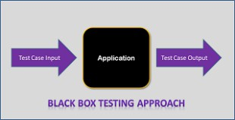

###### How to write Test Cases for Black Box Testing?

* The tester examines requirements and specifications of the system.
* The tester explores the system’s UI and functionality to understand how the processes on the system are expected to work.
* Tester designs test cases with valid inputs and the corresponding expected outputs.
* Tester also includes some negative test cases with invalid inputs and expected outputs (error messages/program termination)0 as applicable.

###### Techniques of Black Box Testing

In case of black box testing, inputs to the test cases are the driving factor. Any one of the three techniques discussed below can be used to choose the inputs during the black box testing process

###### Boundary Value Analysis:

This approach is focused on testing the boundary values associated with the system. This approach aims at testing the boundaries of the input domain that have the highest probability of giving erroneous outputs.

###### Equivalence Class Partitioning:

In this approach, a limited set of functions is identified along with its corresponding valid and invalid inputs and expected outputs. This approach aims at identifying classes of errors and therefore reducing the number of test cases required.

###### Error Guessing:

An experienced tester most often uses this approach to first identify the defects and then develop corresponding test cases.

**EXAMPLE :**

* A tester, without knowledge of the internal structures of a website, tests the web pages by using a browser; providing inputs(clicks, keystrokes) and verifying the outputs against the expected outcome.

###### Debugging :

Debugging occurs as a consequence of successful tesing. That is when a test. Uncovers an error, debugging is the process that results in the removal of the error. Although debugging can and should be an orderly process , it is still very much an art. A software engineer, evolution the results of test is often confronted with a “symptomatic” indication of software problem. That is, the external manifestation of the error and the internal cause of the error may have no obvious relationship to one another. The poorly understood mental process that connects a symptom to cause is debugging. Debugging is not testing but if always occurs as a consequence of test

## 6.SCREEENSHOTS

**User Interface**

**User Login & Register interface**

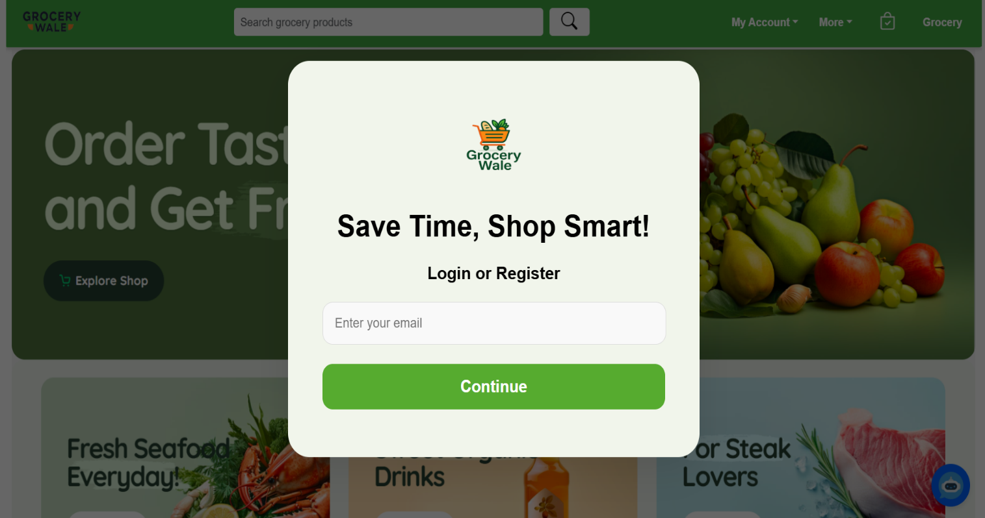

**Admin Login page:**

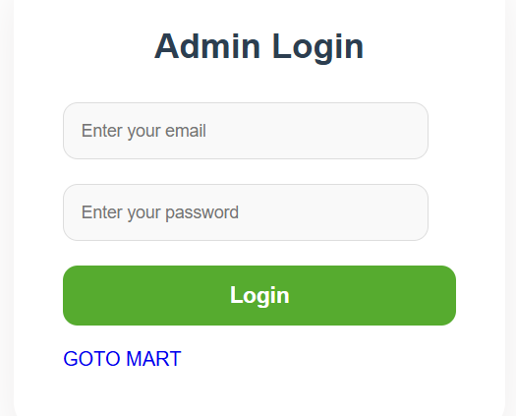

**Admin manage user page:**

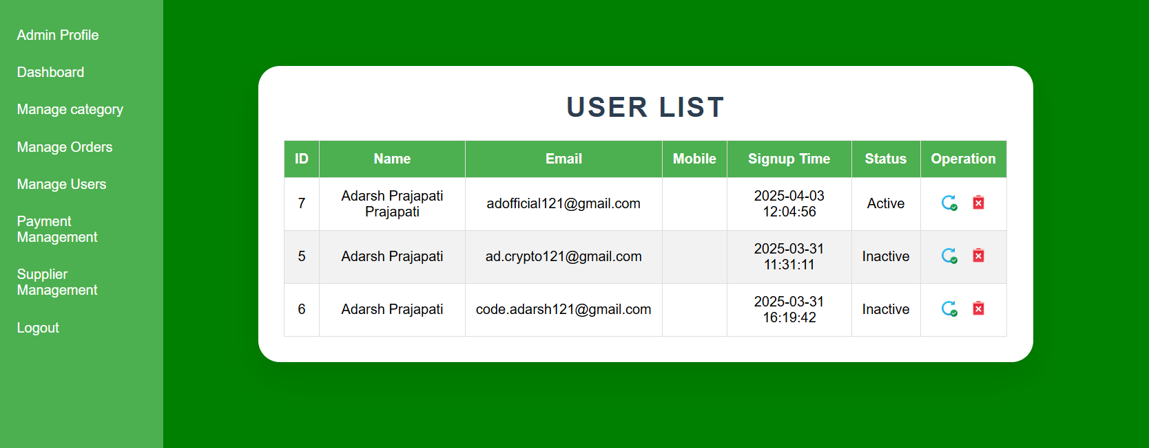

**Admin manage categories**

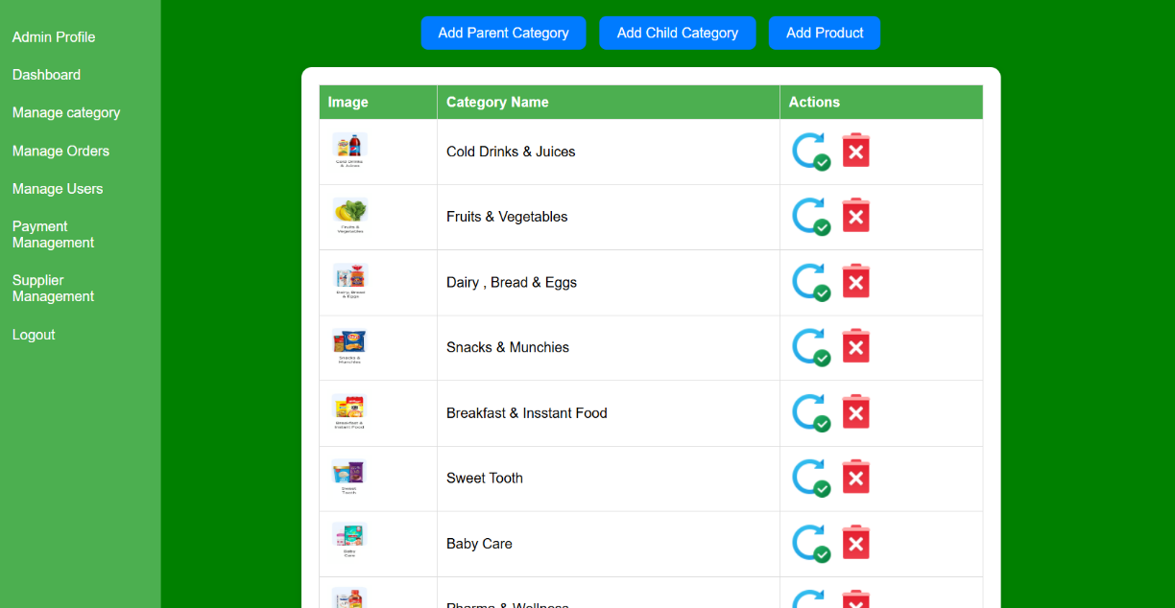

# Parent Category interface

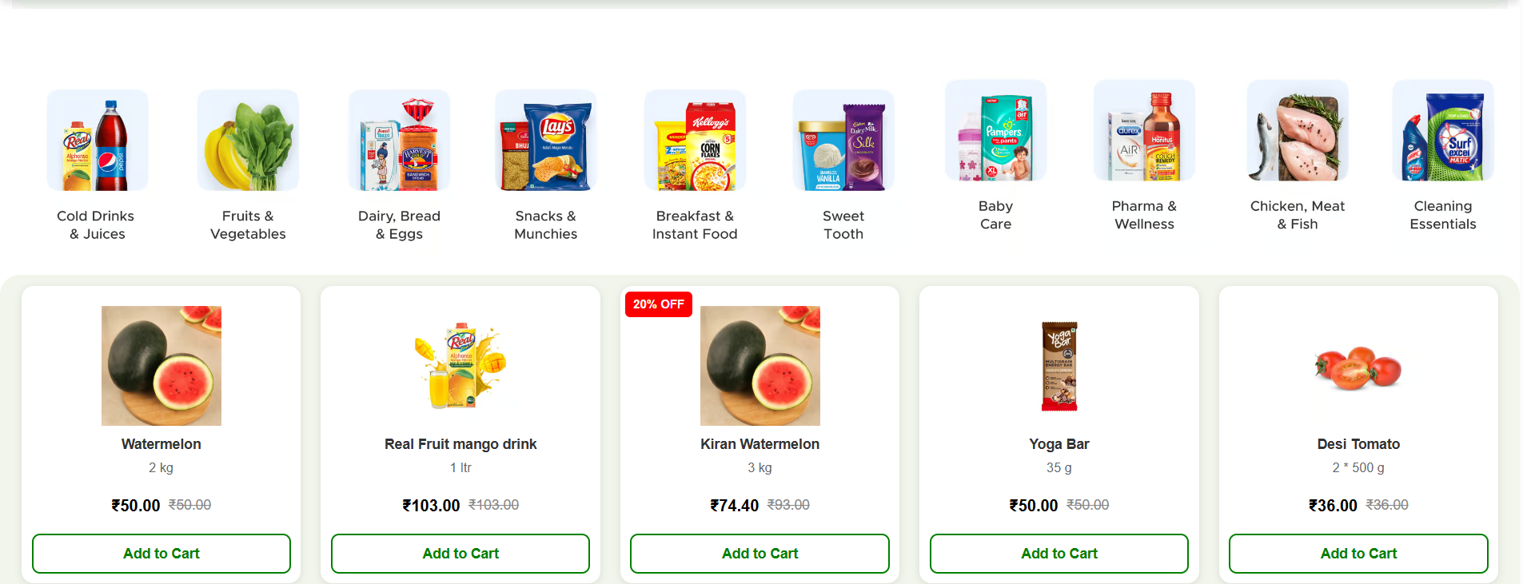

## Cart

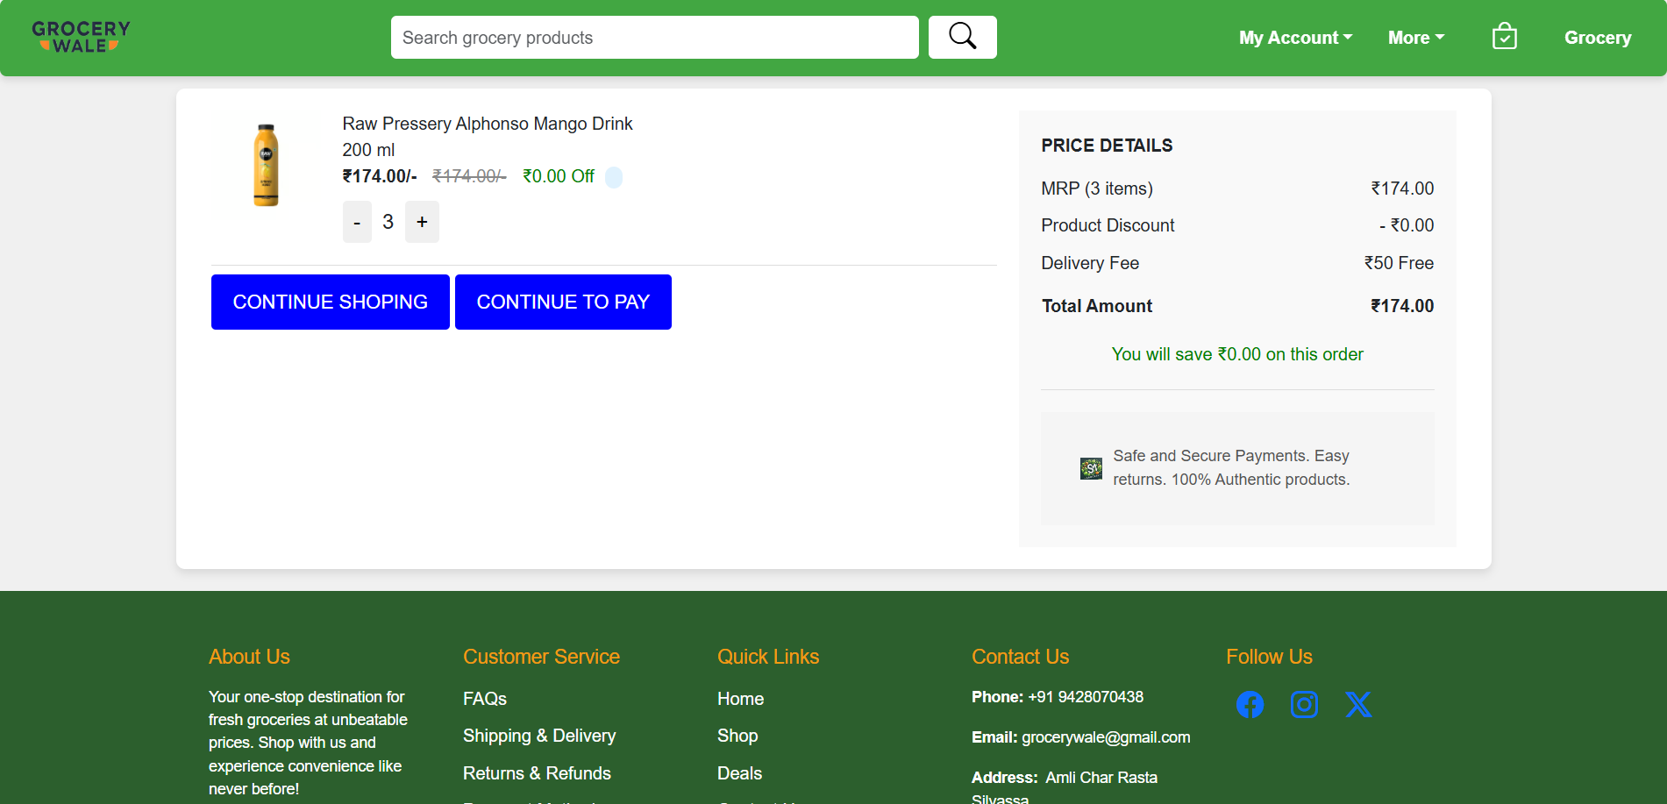

**Payment interface**

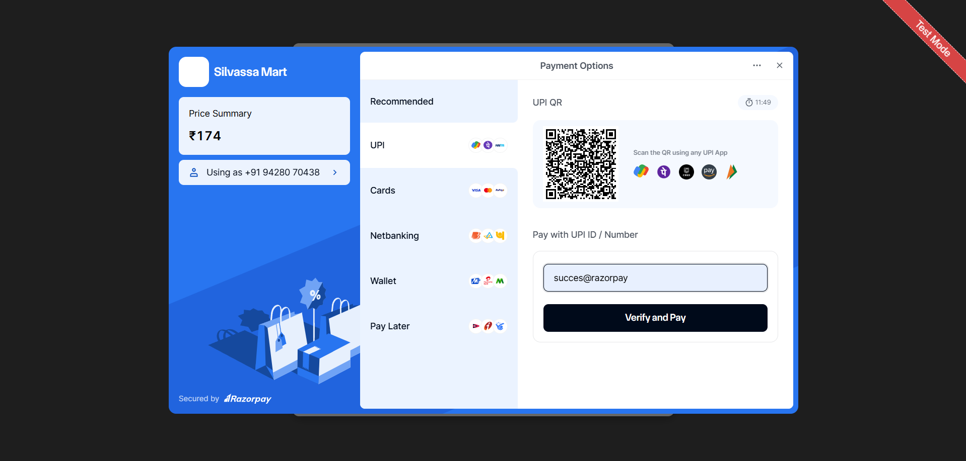

## BIBLOGRAPHY

This document contains provisions which, through reference in this text, constitute provisions of the present document.

1. Google Search Engine for various searching
2. Web-Technologies Black Book
3. Keeves PHP- MYSQL
4. Worx Press – Beginning PHP5
5. Online at [www.w3schools.org](http://www.w3schools.org/)
6. Murch’s-PHP/MYSQL
7. <https://www.amazon.in/>
8. <https://www.flipkart.com/>